Prepositions of Agent or Instrument

🔹 What Are Prepositions of Agent or Instrument?
# Source: AI Source: Provided by: [Data Path: Persons Table -> ID Column: 1, Name_En Column: Motasem Essam] -> From: [Chatgpt (GPT-4-turbo)] on [7/28/2025]
Prepositions of agent or instrument show who or what causes or performs an action, or what tool/method is used to do it.
They answer:
- By whom? → Agent
- By what means? With what? → Instrument

✅ Common Prepositions of Agent and Instrument
# Source: AI Source: Provided by: [Data Path: Persons Table -> ID Column: 1, Name_En Column: Motasem Essam] -> From: [Chatgpt (GPT-4-turbo)] on [7/28/2025]
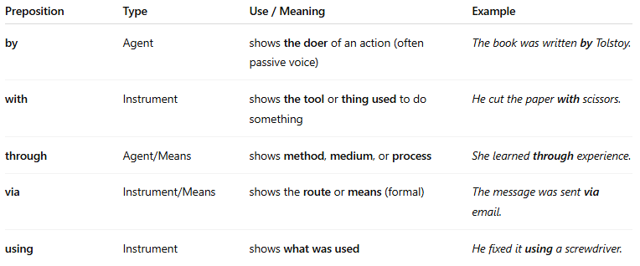
Preposition | Type | Use / Meaning | Example
by | Agent | shows the doer of an action (often passive voice) | The book was written by Tolstoy.
with | Instrument | shows the tool or thing used to do something | He cut the paper with scissors.
through | Agent/Means | shows method, medium, or process | She learned through experience.
via | Instrument/Means | shows the route or means (formal) | The message was sent via email.
using | Instrument | shows what was used | He fixed it using a screwdriver.

📚 Example Sentences
# Source: AI Source: Provided by: [Data Path: Persons Table -> ID Column: 1, Name_En Column: Motasem Essam] -> From: [Chatgpt (GPT-4-turbo)] on [7/28/2025]
- The painting was created by a famous artist.
- She opened the can with a knife.
- The data was collected through surveys.
- I sent the file via WhatsApp.
- The machine was built using recycled parts.

